Name:________________________
5.2 Verifying Identities  Homework

Show that the left side side is equal to the right side. Remember to work only the left side (no crossing over). 20 pts ( 2 pts each)

- 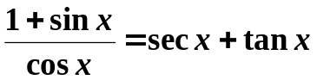

2) 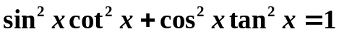

3) 

4) 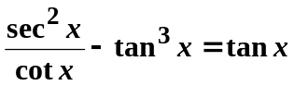

5) 

6) 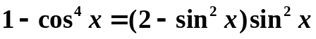

7)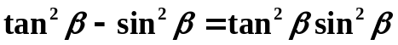

8) 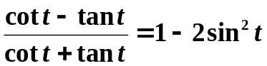

9) 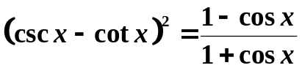

10) 